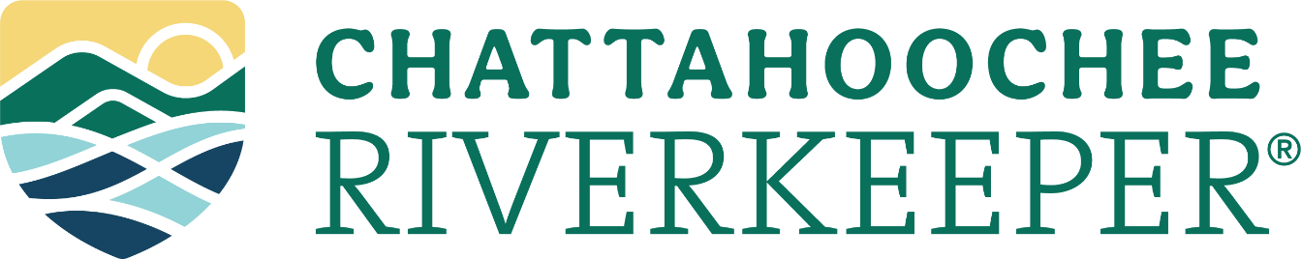

Trash Trap Fellowship

Chattahoochee Riverkeeper (CRK) is a nonprofit, environmental advocacy and education organization with more than 10,000 members and offices in Atlanta, Gainesville and LaGrange that works to protect the Chattahoochee River and its tributaries through education, monitoring, outreach, and legal actions.

CRK is seeking a fellow in its Atlanta office to assist with its trash trap program. The fellow will work with the Watershed Protection Specialist to conduct in-stream litter collection and data analysis as part of the organization’s work toward a trash-free Chattahoochee. The fellow should be self-motivated, have a strong work ethic, and be comfortable working outdoors. Fellows will receive valuable real-world and professional experience, networking opportunities with partners and sponsors, and will be an essential asset to CRK’s vital work. For more information about CRK’s trash traps, visit: https://chattahoochee.org/our-work/in-stream-trash-removal/

Primary Duties:
- Coordinate grant-related activities and reporting with CRK staff;
- Clean out trash traps between heavy rain events, maintain devices as necessary;
- Conduct forensic trash assessments and manage trash collection metrics;
- Data management and analysis;
- Assist online outreach campaigns, educational seminars, and community engagement events.
Desired Skills:
- Bachelors degree in a technical field, or working towards a degree;
- Basic understanding of water quality;
- Ability to synthesize information from multiple sources;
- Ability to think strategically and work independently;
- Ability to operate a motor vehicle and work in physically demanding field conditions;
- Attention to safety and consistency;
- Good writing, organization, and communication skills;
- Proficiency in Microsoft Excel, Microsoft Word, and an interest in data visualization.
- Experience with GIS a plus
Compensation: $13/hour
Time commitment: 16 hours/week
Application due date: Open until filled
To apply: Email a resume/CV to Jordan Yu, Watershed Protection Specialist (jyu@chattahoochee.org)

Chattahoochee Riverkeeper is an equal opportunity employer and considers candidates for employment without regard to race, color, creed, national origin, religion, age, gender, marital status, or sexual orientation.

